**Want to be a Master Gardener?**



**Every year in County Extension Offices across the state, Master Gardener volunteer training is conducted by AgriLife Extension for adults interested in gardening, horticulture and related topics.**

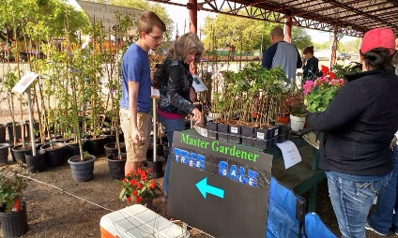

A new class will begin January 13th and end April 7th. Persons that are interested in joining the class are asked to fill out an application that is available at the Extension Office, 101 E. Oak Street, Palestine, TX. For more information about the program contact the Extension Office, 903-723-3735.

Deadline to register is January 2, 2020

**Texas A&M AgriLife Extension provides equal opportunities in its programs and employment to all persons, regardless of race, color, sex, religion, national origin, disability, age, genetic information, veteran status, sexual orientation, or gender identity.**

The Texas A&M University System, U.S. Department of Agriculture, and the County Commisioners Courts of Texas Cooperating